CHAPTER 3
Where Prices Come From:
The Interaction of Demand and Supply
- Chapter Summary
- Learning Objectives
- Chapter Outline
Teaching Tips/Topics for Discussion
- Solved Problems
- Solutions to Review Questions and Problems and Applications

1. Chapter Summary
The model of supply and demand explains how prices are determined in a market system.
The most important factor affecting the demand for a product is its price. A demand schedule lists various prices of a product and the quantities demanded at these prices. A demand curve shows this same relationship in a graph. The law of demand is the negative relationship between price and quantity demanded, holding everything else constant. Other factors that affect demand include prices of related goods (substitutes and complements), income, tastes, population and demographics, and expected future prices. Responses to changes in any of these shift a product’s demand curve and are referred to as changes (increases or decreases) in demand.
The most important factor affecting the supply for a product is its price. A supply schedule lists various prices of a product and the quantities supplied at these prices. A supply curve shows this same relationship in a graph. The law of supply is the positive relationship between price and quantity supplied, holding everything else constant. Other factors that affect supply include prices of inputs, technological change, prices of substitutes in production, expected future prices, and the number of firms in the market. In response to a change in any one of these factors, there will be a change in supply or a shift in the supply curve.
The intersection of demand and supply curves results in an equilibrium price. A surplus exists when the market price is above the equilibrium price. A shortage exists when the market price is below the equilibrium price. When the market price equals the equilibrium price, both consumers and producers are willing to exchange the same quantity of the product and there is no further movement in the market price.
An increase in demand increases equilibrium price and increases the equilibrium quantity. A decrease in demand decreases equilibrium price and decreases the equilibrium quantity. An increase in supply decreases equilibrium price and increases the equilibrium quantity. A decrease in supply increases equilibrium price and decreases the equilibrium quantity.

2. Learning Objectives
Students should be able to:
- Discuss the variables that influence demand.
- Discuss the variables that influence supply.
- Use a graph to illustrate market equilibrium.
- Use demand and supply graphs to predict changes in prices and quantities.

3. Chapter Outline
How Hewlett-Packard Manages the Demand for Printers
1. Although Hewlett-Packard is a leading seller of printers in the United States, it faces competition from other firms that sell printers. Hewlett-Packard also sells other related products in competition with other firms.
►Teaching tips: Making the Connection 3-3 describes efforts by Hewlett-Packard to forecast the demand for its products. At the end of this chapter, An Inside Look describes the competition Hewlett-Packard faces in the markets for personal computers and printers. These readings can be used as the basis for classroom discussion, homework assignments or examination questions regarding the significance of competition in the market for computers and printers. These markets also feature examples of factors that cause shifts in demand (for example, personal computers and printers are complementary goods) and supply (for example, positive technological change reduces the costs of computers).
The Demand Side of the Market
1. Many factors influence the willingness and ability of consumers to buy a particular product. The main influence on consumer decisions will be the price of the product.
- Quantity demanded is the amount of a good or service that a consumer is willing and able to purchase at a given price.
- A demand schedule is a table showing the relationship between the price of a product and the quantity of the product demanded.
- A demand curve shows the relationship between the price of a product and the quantity of the product demanded.
  - A demand curve may be constructed for each individual consumer in a market.
  - A market demand curve shows the total demand of all consumers in a market.
- The law of demand states that holding everything else constant, when the price of a product falls, the quantity demanded of the product will increase, and when the price of a product rises, the quantity demanded of the product will decrease. The law of demand is explained by the substitution and income effects.
  - The substitution effect is the change in quantity demanded of a good that results from a change in price, making the good more or less expensive relative to other goods that are substitutes.
  - The income effect is the change in the quantity demanded of a good that results from the effect of a change in the good’s price on consumer purchasing power.
2. Ceteris paribus (“all else equal”) is the requirement that when analyzing the relationship between two variables – such as the price and quantity demanded – other variables must be held constant.
- Factors other than price influence demand.
- When one of the non-price factors that influence demand changes, a shift in demand – an increase or decrease in demand – results.
- The following are the most important non-price influences on demand.
- Prices of related goods
- Income
- Tastes
- Population and demographics
- Expected future prices
3. There are two types of related goods:
  - Substitutes are goods and services that can be used for the same purpose.
    - A decrease in the price of a substitute for good A causes the demand curve for good A to shift to the left.
    - An increase in the price of a substitute for good A causes the demand for good A to shift to the right.
  - Complements are goods that are used together.
    - A decrease in the price of a complement for good B causes the demand for good B to shift to the right.
    - An increase in the price of a complement for good B causes the demand for good B to shift to the left.
4. The income that consumers have available to spend affects their willingness to buy a good.
- A normal good is a good for which the demand increases as income rises and decreases as income falls.
- An inferior good is a good for which the demand increases as income falls, and decreases as income rises.
5. Changes in tastes, demographics, and expected future prices can affect the demand for a good.
- When consumers’ taste for a product increases, the demand curve for the product will shift to the right, and when consumers’ taste for a product decreases, the demand curve for the product will shift to the left.
- As population increases, the demand for most products increases. Demographics are the characteristics of a population with respect to age, race, and gender. As demographics change, the demand for particular goods will increase or decrease because different categories of people will have different preferences for those goods.
- If enough consumers become convinced that a good will be selling for a lower price some time in the future, the demand for the good will decrease in the present; if enough consumers become convinced that the price of a good will be higher some time in the future, the demand for the good will increase in the present.
►Teaching tips: There is no magic formula for making students understand the difference between a change in quantity demanded and a change in demand. One needs to reinforce this through classroom discussion, use of examples of these changes, and homework assignments. Even good students mistake a movement along a demand curve with an increase or a decrease in demand. The simplest way to explain this error is to note that only one variable can cause a change in quantity demanded (price), whereas a change in any of the non-price factors results in a change in demand. Constant repetition is essential. Use Making the Connection 3-1 and Making the Connection 3-2 to find examples of factors that change demand. Ask students: “Why don’t the events described in these readings result in changes in quantity demanded?”
The Supply Side of the Market
1. Many variables influence the willingness of firms to sell a good or service. The most important of these variables is price.
- Quantity supplied is the amount of a good or service that a firm is willing and able to supply at a given price.
- A supply schedule is a table that shows the relationship between the price of a product and the quantity of the product supplied.
- A supply curve is a curve that shows the relationship between the price of a product and the quantity of the product supplied. A supply curve may be constructed for each firm in a market or for the market as a whole.
- The law of supply states that, holding everything else constant, increases in price cause increases in the quantity supplied, and decreases in price cause decreases in the quantity supplied.
2. Variables other than price affect supply. When any of these variables change, a shift in supply – an increase or a decrease in supply – results. The following are the most important variables that shift supply.
- Prices of inputs
- Technological change
- Prices of substitutes in production
- Expected future prices
- Number of firms in the market
3. If the price of an input used to produce a good rises, the supply for the good will decrease; the supply curve will shift to the left. If the price of an input decreases, the supply for the good will increase; the supply curve will shift to the right.
4. Technological change is a positive or negative change in the ability of a firm to produce a given level of output with a given amount of inputs. A positive technological change will shift a firm’s supply curve to the right; a negative technological change will shift a firm’s supply curve to the left.
5. An increase in the price of an alternative good (good B) that a firm could produce will shift the firm’s supply curve (good A) to the left.
6. If a firm expects that the price of its product will rise in the future, the firm has an incentive to decrease supply in the present and increase supply in the future.
7. When firms enter a market, the supply curve shifts to the right; when firms exit a market, the supply curve shifts to the left.
►Teaching tips: Students usually accept the law of supply because it seems logical to them: producers will make more profit when the price of their products rises. One may not want to spend valuable class time on a more extended explanation, but consider Figure 3-7 and the following question: “If Hewlett-Packard can earn a profit from selling 9 million printers per month at a price of $125, why not increase quantity supplied to 10 million and make even more profit?” The upward slope of the supply curve is due not only to the profit motive, but also to the increasing marginal cost of printers. (Recall that increasing marginal costs were discussed in Chapter 2.) Hewlett-Packard will increase its quantity supplied from 9 to 10 million in Figure 3-7 only if the price it will receive is $175; in other words, the marginal cost of producing the additional one million printers must be greater than the cost of the other printers.

As with demand and quantity demanded, students must be cautioned not to confuse a change in quantity supplied (due only to a change in the price of a product) and a change in supply (a shift of the supply curve in response to one of the non-price factors). Constant reinforcement of this is necessary. Be careful not to refer to an increase in supply as “a downward shift” or a decrease in supply as “an upward shift.” Increases in supply should be referred to as a “rightward shift.” Since demand curves are downward-sloping, an increase in demand appears in a graph as an “upward shift.” Students will associate “upward” with “increase.” Little harm is done with respect to demand curves. But since supply curves are upward-sloping, a decrease in supply appears in a graph as an “upward shift.” One should consistently refer to both changes in demand and supply as being “shifts to the right” and “shifts to the left” in order to avoid confusion.
Market Equilibrium: Putting Demand and Supply Together
1. The purpose of markets is to bring buyers and sellers together. The interaction of buyers and sellers in markets results in firms producing goods and services most desired by consumers.
- Market equilibrium is a situation where quantity demanded equals quantity supplied. A competitive market equilibrium is a market equilibrium with many buyers and many sellers.
- A surplus is a situation in which the quantity supplied is greater than the quantity demanded.
- A shortage is a situation in which quantity demanded is greater than the quantity supplied.
2. When there is a surplus, the market price is above the equilibrium price. Firms have an incentive to increase sales by cutting the price. Quantity demanded will rise and quantity supplied will fall until the market reaches equilibrium.
3. When there is a shortage, the market price is below the equilibrium price. Some consumers have an incentive to offer to buy the product at a higher price. Quantity demanded will fall and quantity supplied will rise until the market reaches equilibrium.
4. At competitive market equilibrium, there is no reason for the price to change unless either the demand curve or the supply curve shifts.
►Teaching tips: The importance of understanding how demand and supply interact to reach equilibrium can’t be overstated. Remind students that adjustments to a shortage and a surplus reflect changes in quantity demanded (not demand) and quantity supplied (not supply).
Assign Solved Problem 3-1, and Problem 3 of the Problems and Applications section at the end of the chapter to reinforce students’ understanding of these topics.
The Effect of Demand and Supply Shifts on Equilibrium
1. An increase in supply results in a lower equilibrium price and greater equilibrium quantity. This will be caused by the following non-price factor changes.
- A decrease in an input price.
- Positive technological change.
- A decrease in the price of a substitute in production.
- A lower expected future product price.
- An increase in the number of firms in the market.
2. A decrease in supply results in a higher equilibrium price and a lower equilibrium quantity. This will be caused by the following non-price factor changes.
- An increase in an input price.
- Negative technological change.
- An increase in the price of a substitute in production.
- A higher expected future product price.
- A decrease in the number of firms in the market.
3. An increase in demand results in a higher equilibrium price and greater equilibrium quantity. This will be caused by the following non-price factor changes.
- An increase in the price of a substitute good.
- A decrease in the price of a complement.
- An increase in income for a normal good.
- A decrease in income for an inferior good.
- An increase in population or an appropriate change in demographics.
- An increase in the expected future price of a product.
4. A decrease in demand results in a lower equilibrium price and lower equilibrium quantity. This will be caused by the following non-price factor changes.
- A decrease in the price of a substitute good.
- An increase in the price of a complement.
- A decrease in income for a normal good.
- An increase in income for an inferior good.
- A decrease in population or an appropriate change in demographics.
- A decrease in the expected future price of a product.
►Teaching tips: Students should be encouraged to review Making the Connection 3-4, Solved Problem 3-2 and Problem 13 of the Problems and Applications section at the end of the chapter to reinforce their understanding of the impact of changes in supply and demand on equilibrium price and quantity. Ask students to find the current prices of watermelons and lobsters at local markets and to ask the proprietors of these markets if the prices of these items change over time as suggested by these problems. Ask students to draw demand and supply curves that explain these price differences.
Don’t Let This Happen To You! warns students not to associate a shift in demand or supply with a change in the price of a good.

4. Solved Problems
Chapter 3 of the textbook includes two Solved Problems that support Learning Objectives 3 (Use a graph to illustrate market equilibrium) and 4 (Use demand and supply graphs to predict changes in prices and quantities). The following are additional Solved Problems that support the other learning objectives from this chapter.

Solved Problem 3-3 Supports Learning Objective 1: Discuss the variables that influence demand

Welcome to the Tostitos Fiesta Bowl!

For many years corporations bought time during college football bowl games to advertise their products. During the latter part of the twentieth century, a new form of sponsorship emerged, as corporations bought naming rights to most of these bowl games. The Sugar Bowl, Orange Bowl and Fiesta Bowl are now known as the Nokia Sugar Bowl, the FedEx Orange Bowl and the Tostitos Fiesta Bowl. Another 24 football bowl games have been named after corporate sponsors. Although many diehard football fans complain about the practice, bowl organizers welcome the revenue generated through the sale of naming rights.
(a) How does corporate sponsorship affect the demand for the sponsor’s product?
(b) Why have so many companies purchased naming rights rather than buy time to broadcast commercials during football bowl games?

Solving the Problem:
Step 1: Review the chapter material. This refers to a variable that shifts a market demand curve. You may want to review the section “Variables That Shift Market Demand,” which begins on page 68 of the textbook.
Step 2: Identify the variable affected by corporate sponsorship. Consumers can be influenced by an advertising campaign to buy a sponsor’s product. Consumer tastes are affected by advertising. Tastes refer to a composite category that represents many subjective factors.
Step 3: Explain why naming rights have become a popular alternative to commercials. Cable and satellite television offer consumers many more programming choices than were available to viewers in the 1950s and 1960s. Remote controls are now included with all new television sets. These controls allow viewers to change channels during commercial breaks without leaving their seats; mute buttons silence commercial messages with the touch of a finger. Although advertisers cannot be guaranteed their commercials will be seen and heard, naming rights are not affected by remote controls. Newspaper and magazine articles refer to the sponsor’s name whenever the bowl game’s title is used, and company logos appear on screen during the broadcasts of the games.

Solved Problem 3-4 Supports Learning Objective 2: Discuss the variables that influence supply.

To (Soy)bean or Not to (Soy)bean ?

Television programming in Illinois features many commercials directed at farmers. Ads for fertilizer, seed, and farm equipment are as common as commercials for laundry soap and soft drinks. Much of the nation’s corn is grown in Illinois, but the climate and soil conditions in the state are well-suited for growing soybeans as well. Farmers face a choice each year to plant corn or soybeans or a combination of the two crops.
- If both crops can be grown on the same land, why would a farmer choose to produce corn rather than soybeans?
- Which of the variables that influence supply would explain a farmer’s choice to produce soybeans or corn?

Solving the Problem:
Step 1: Review the chapter material. This problem is about variables that shift the supply curve, so you may want to review the section of the textbook “Variables That Shift Supply,” which begins on page 75 of the textbook.
Step 2: Answer question (a). Among the factors that would influence a farmer’s choice is the expected profitability of the two crops. A farmer will grow corn rather than soybeans if he expects the profits from growing corn will be greater than those earned from growing soybeans.
Step 3: Answer question (b). Other things being equal, as the price of soybeans falls relative to the price of corn, the supply of corn would increase. Since corn and soybeans are substitutes in production, the variable “prices of substitutes in production” is the variable that would explain the farmer’s choice.

5. Solutions to Review Questions and Problems and Applications

Answers to Thinking Critically Questions

1. If Dell, IBM, and Gateway refused to cut their prices, their quantity sold would fall.

2. If one manufacturer’s computers were not a good substitute, its quantity sold would not fall by as much if it failed to match the price cut.

Answers to Review Questions

1. In a market system, consumers ultimately decide what is produced.

2. Ceteris paribus means “everything else equal” – that is, holding everything else constant when examining the relationship between two variables.

3. A “change in demand” refers to a shift in a demand curve, while a “change in the quantity demanded” refers to a movement along a stationary demand curve.

4. The law of demand states that, holding everything else constant, when the price of a product falls, the quantity demanded of the product will increase (and when the price of a product rises, the quantity demanded of the product will decrease). The main variables that will cause a demand curve to shift include: 1) changes in the prices of a related good – substitutes or complements, 2) changes in income, 3) changes in tastes, 4) changes in population or demographics, and 5) changes in expected future prices.

5. The law of supply states that, holding everything else constant, an increase in price causes an increase in the quantity supplied (and a decrease in price causes a decrease in the quantity supplied). The main variables that will cause a supply curve to shift include: 1) changes in the prices of inputs used to make the product, 2) technological changes, 3) changes in the prices of substitutes in production (other things that the producers could be making), 4) changes in expected future prices, and 5) changes in the number of firms in the market.

6. Market equilibrium is the situation in which the quantity demanded equals the quantity supplied. If the current price is above equilibrium, there will be excess supply (a surplus) and the price will fall toward equilibrium. If the current price is below equilibrium, there will be excess demand (a shortage) and the price will be pushed up toward equilibrium.

7. When the demand curve shifts to the right, the equilibrium price rises. Figure 3-13 from the text demonstrates this.

8. When the supply curve shifts to the left, the equilibrium price rises. Figure 3-12 from the text demonstrates this.

9. If the demand curve shifts to the right more than the supply curve does, the equilibrium price will rise. Figure 3-14 (a) from the text demonstrates this. If the supply curve shifts to the right more than the demand curve, the equilibrium price will fall. Figure 3-14 (b) from the text demonstrates this.
Answers to End of Chapter Problems and Applications

Answers to End-of-Chapter Problems and Applications

1.
Quantity Demanded
(cones per week)
Price | Pedro | Curt | Tim | Market
$1.75 | 2 | 1 | 0 | 3
1.50 | 4 | 3 | 2 | 9
1.25 | 6 | 4 | 3 | 13
1.00 | 7 | 6 | 4 | 17
0.75 | 9 | 7 | 5 | 21

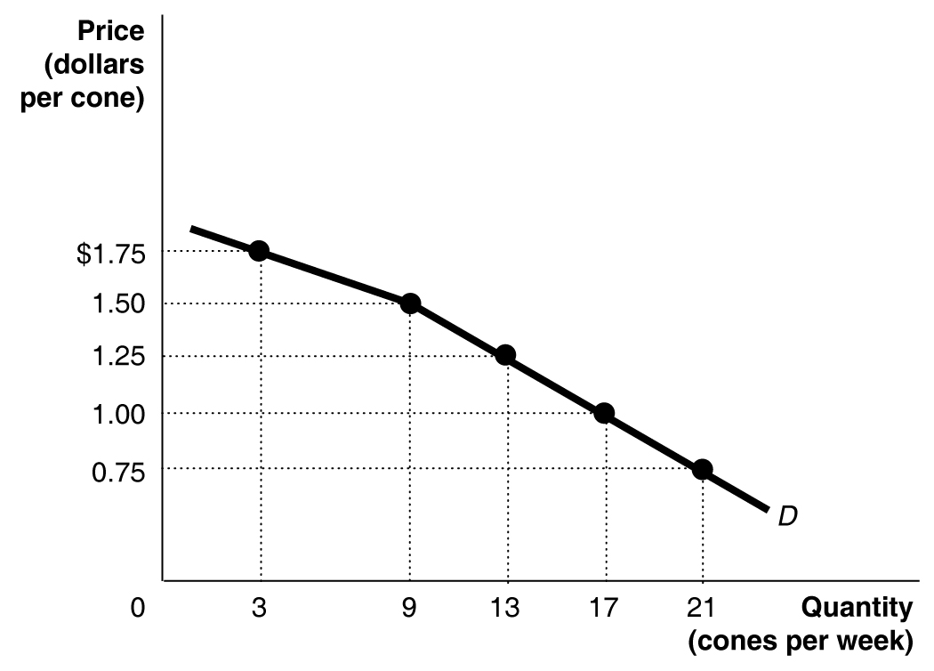

2. a. substitutes
b. complements
c. complements
d. probably unrelated

3. a. The demand curve for Big Macs will shift to the left.
b. There will be a movement down the demand curve for Big Macs.
c. The demand curve for Big Macs will shift to the left (assuming that Big Macs and fries are complements).
d. The demand curve for Big Macs will shift to the right.
See page 71 of the textbook for graphs that shift to the right and to the left.

4. It is possible. For instance, someone who likes the taste of hamburger may consume a larger quantity of hamburgers as his income rises. Another person may only be consuming hamburgers because his income is low. As this person’s income rises, he may substitute steak for hamburger in his diet.

5. The data do not indicate that the demand curve for Explorers is upward sloping. It is likely that factors such as income and the prices of other SUVs have changed during these three years. Therefore, the data are likely to represent points from three different demand curves.

6. The student’s reasoning is incorrect. He should have said: “Increased production leads to a lower price, which increases the quantity demanded.”

7. Scenario a. is shown in the first graph – demand for Pepsi rises because the falling supply of Coke will raise the price of Coke, which is a substitute for Pepsi.
Scenario b. is shown in the fourth graph – demand for Pepsi falls when incomes fall because it is a normal good.
Scenario c. is shown in the third graph – an improvement in technology shifts the supply curve to the right.
Scenario d. is shown in the second graph – a rise in an input’s price shifts the supply curve to the left.

8.
Quantity Supplied
(pizzas per week)
Price | Mark | Mike | Bill | Market
$5.00 | 25 | 30 | 20 | 75
5.50 | 30 | 40 | 25 | 95
5.75 | 35 | 50 | 30 | 115
6.00 | 40 | 60 | 35 | 135
6.25 | 45 | 70 | 40 | 155

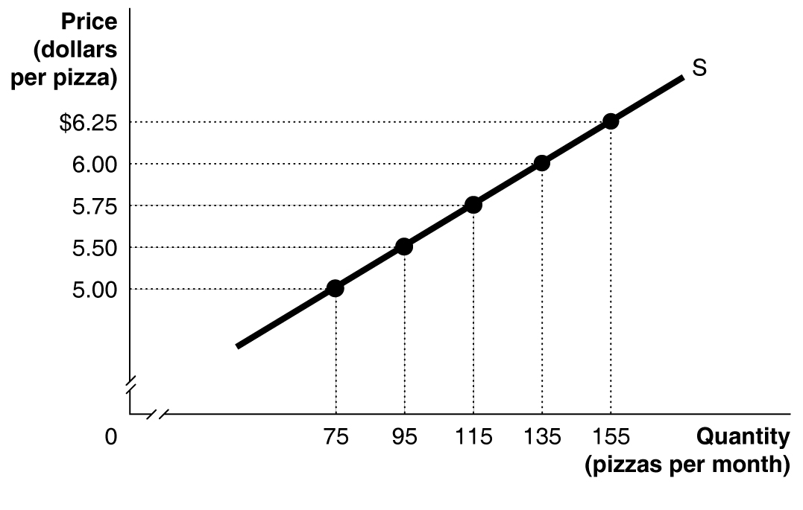

9.

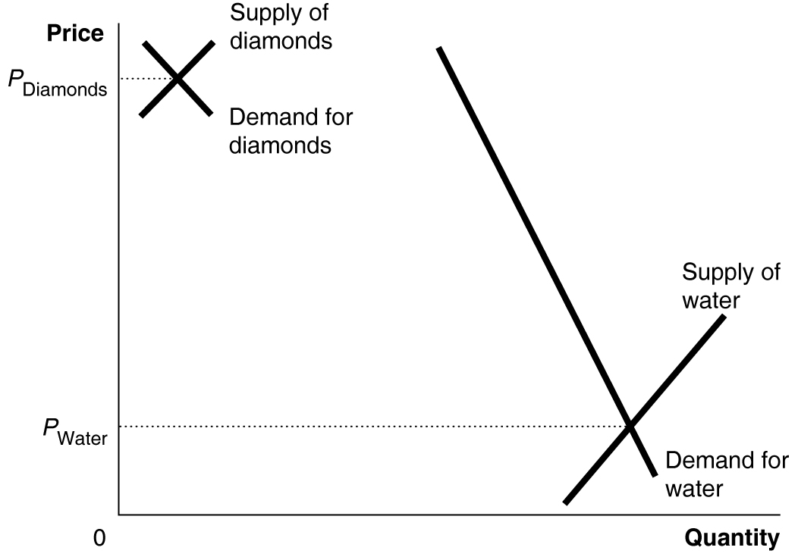

10. Zero would be the equilibrium quantity if the supply curve is always above the demand curve – that is, if the lowest price at which anyone is willing to supply the good is above the highest price that anyone is willing to pay for the good. The quantity supplied and the quantity demanded will be zero in such a market.

11. a.

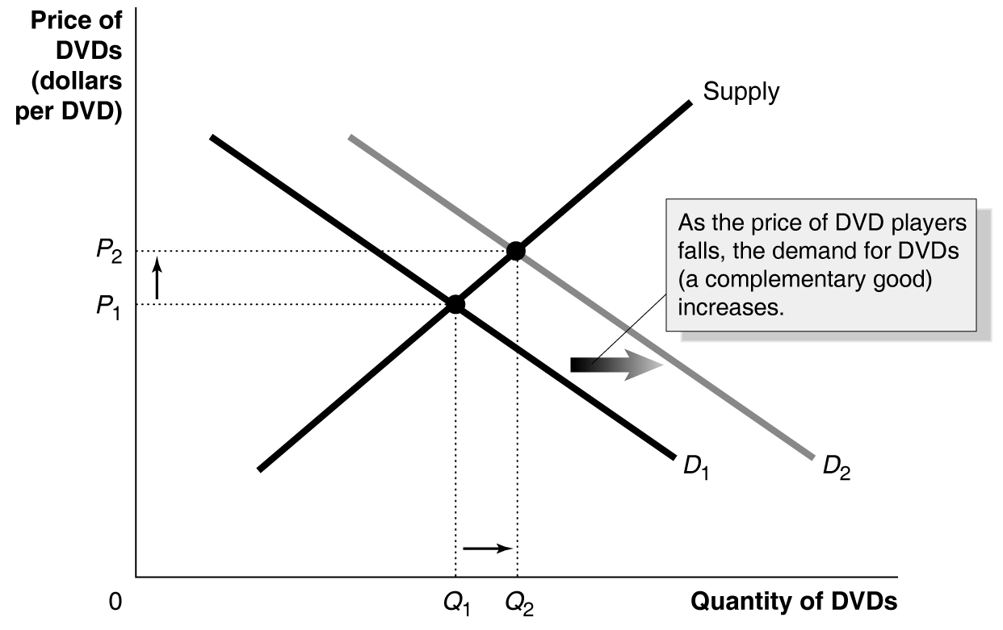

11. b.
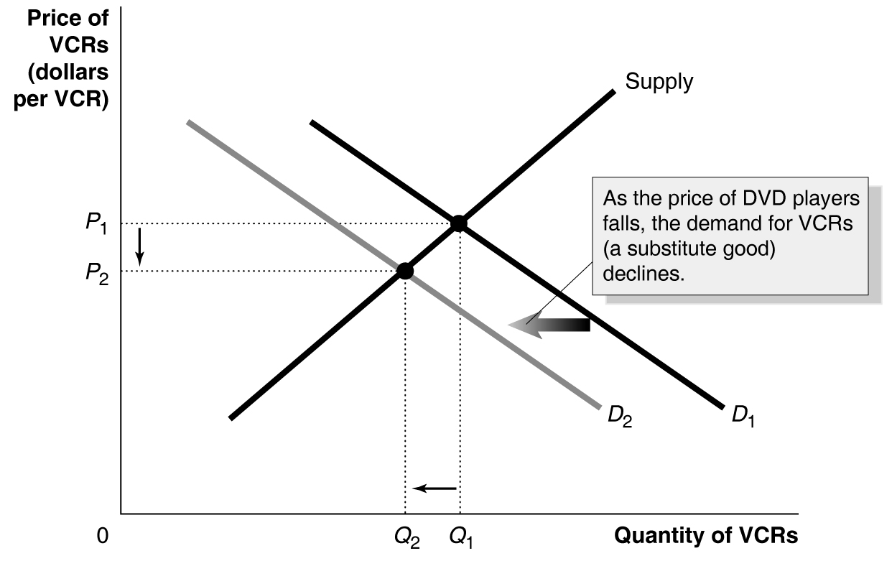

12. a. Complements
b. The answer to problem 12. b. consists of the following two graphs:

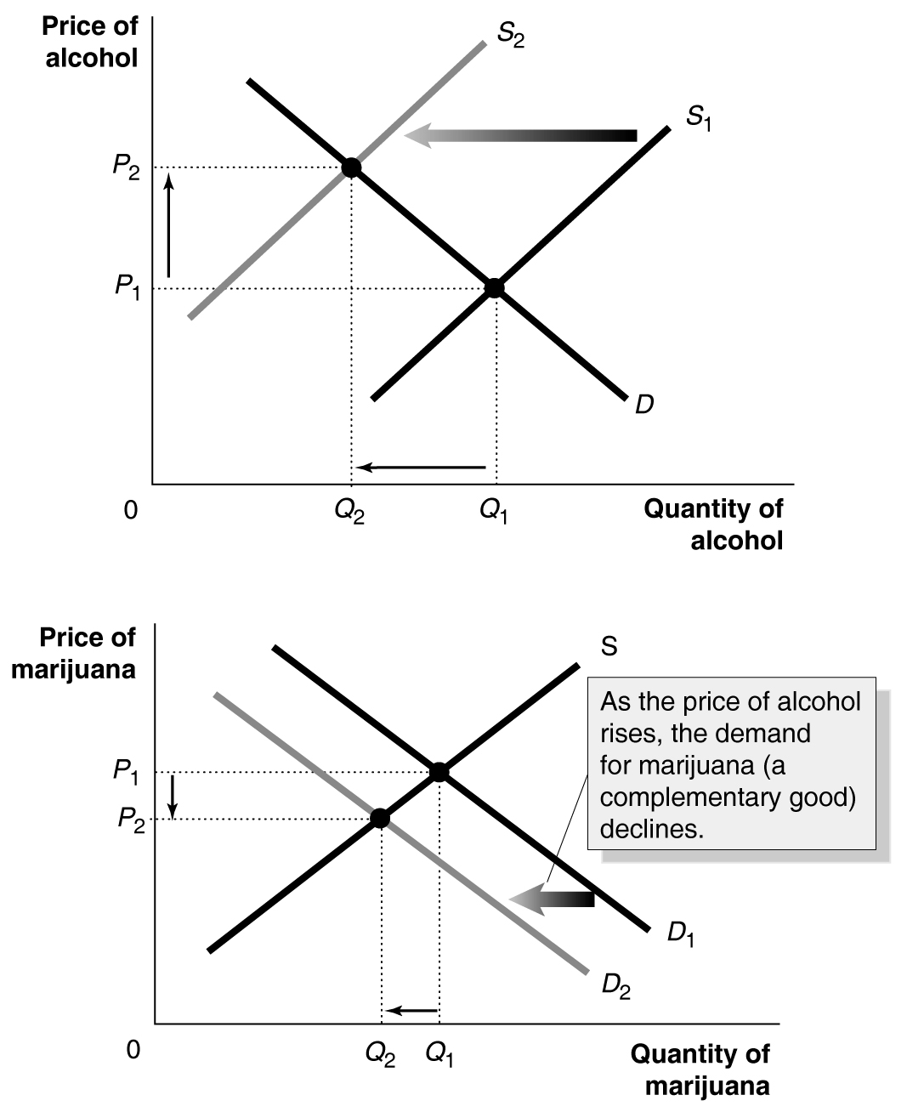

13.

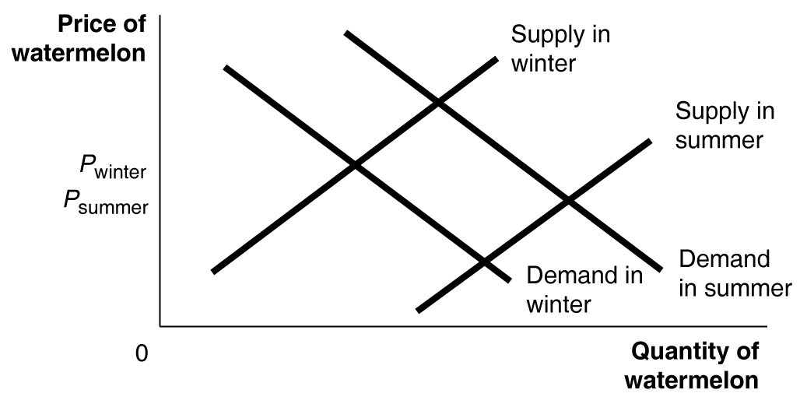

14. a. The supply of corn must be falling if output is falling and prices are rising. The fall in the corn supply may be due to farmers switching over to soybean production in response to higher soybean prices. The demand for soybeans must be increasing if the price rises when supply is increasing.

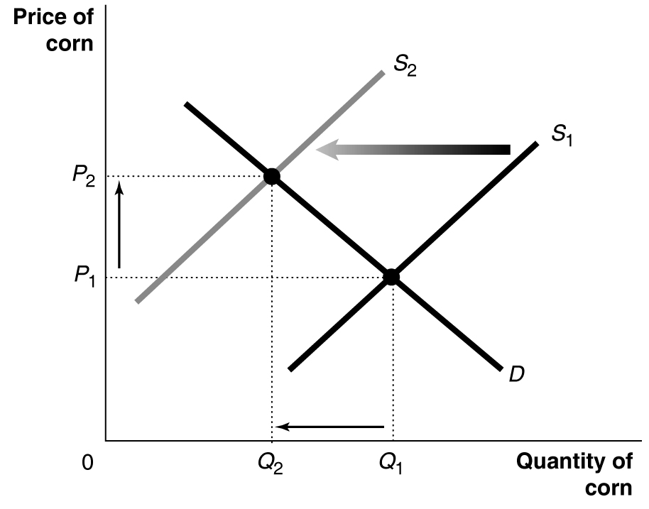

14. b.
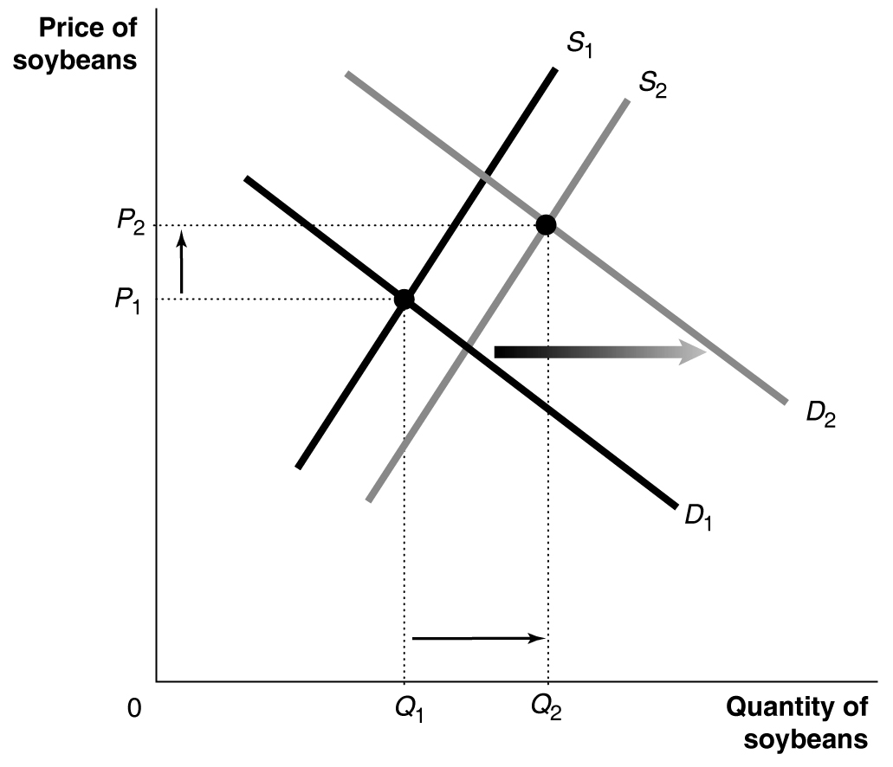

15. The quantity of flat screen televisions sold during this period must have increased.

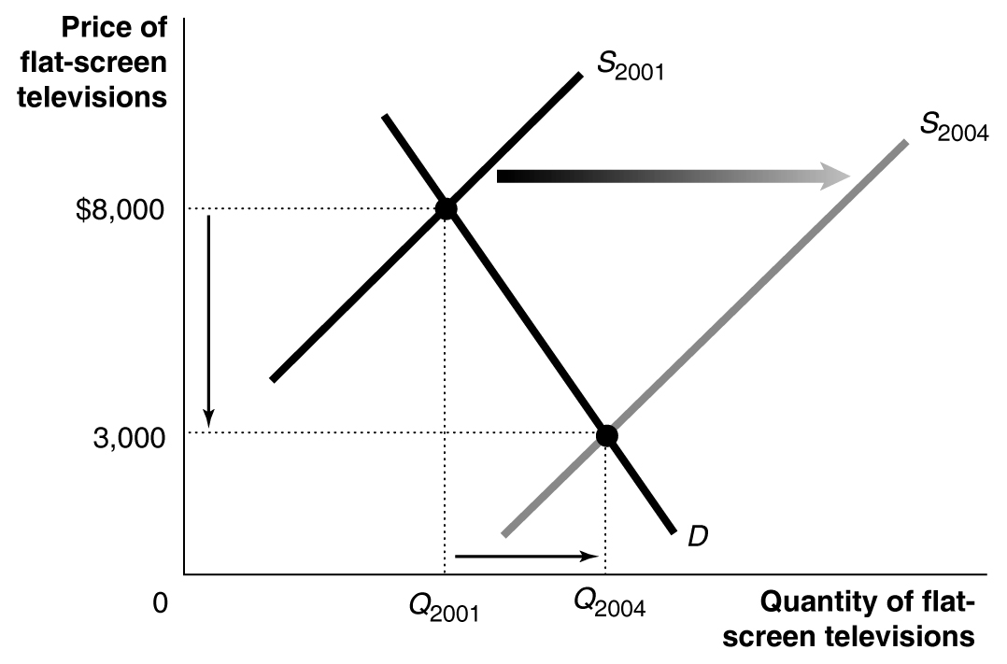

16. The graph shows that there was a surplus of commercial real estate in the San Francisco market. The difference between Q₂ and Q₁ is four million square feet. Whenever there is a surplus in a market, we expect that the price will fall.

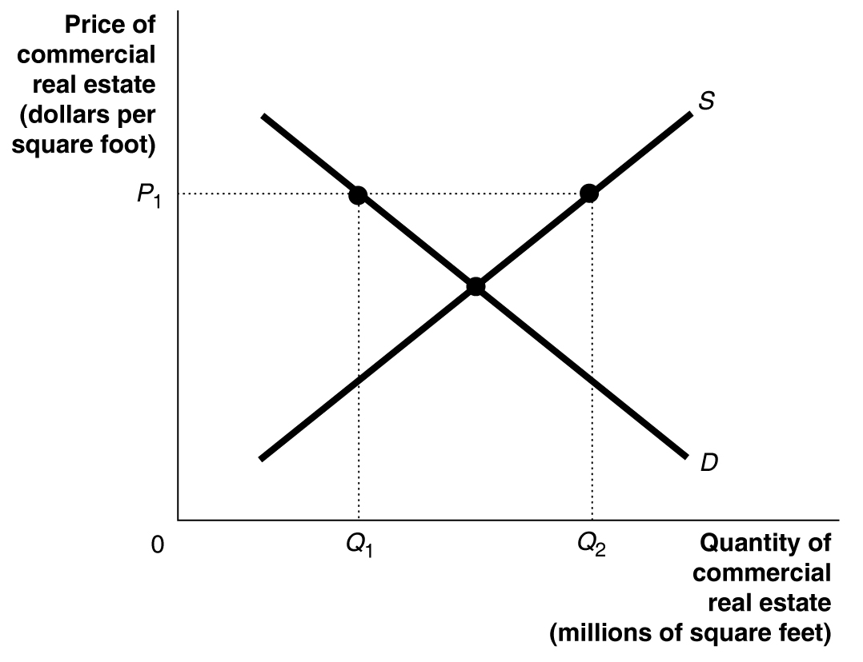

17. Doubts about the safety of laser eye surgery will cause the demand curve to shift to the left, and falling prices for eye surgery machinery will cause the supply curve to shift to the right. The equilibrium price will definitely fall, but the equilibrium quantity may rise or fall depending upon the size of the shifts in supply and demand. If the supply curve shifts right less than the demand curve shifts left, as shown in the figure, quantity will fall. But if the supply curve shifts right more than the demand curve shifts left, quantity will rise.

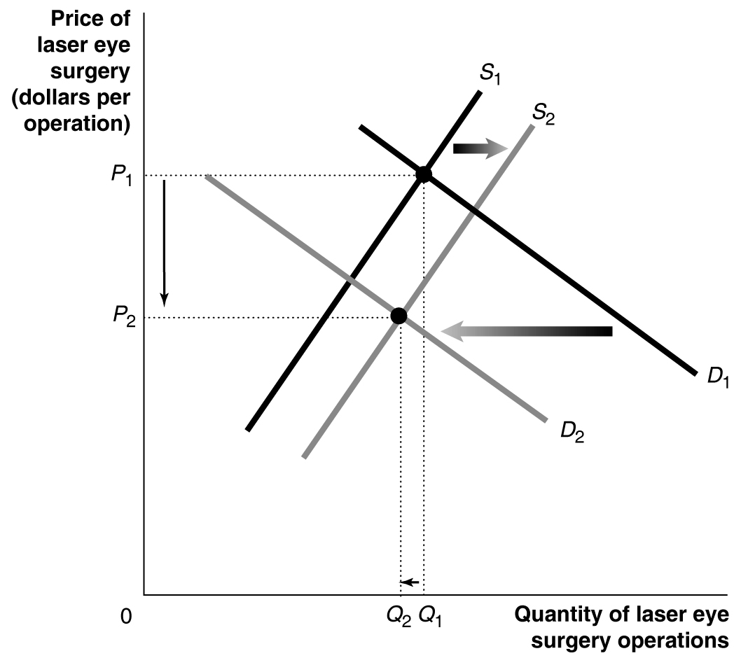
18.

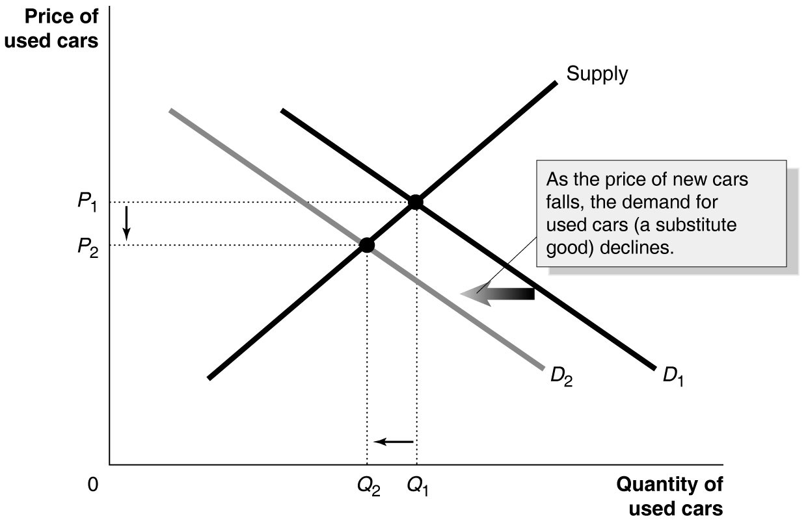
19. a.

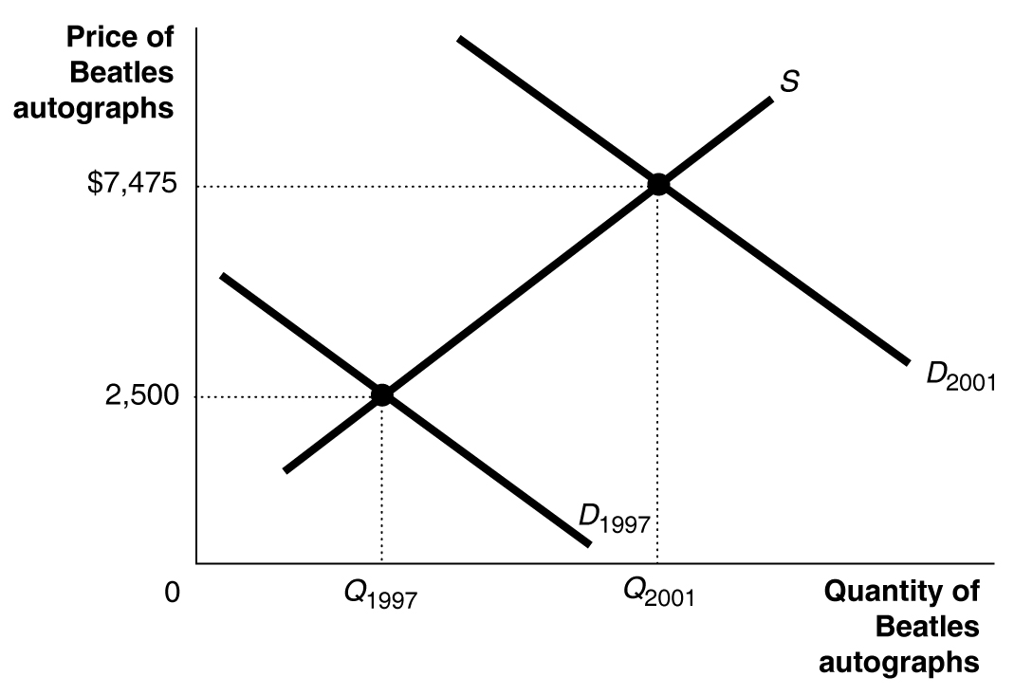
19. b.
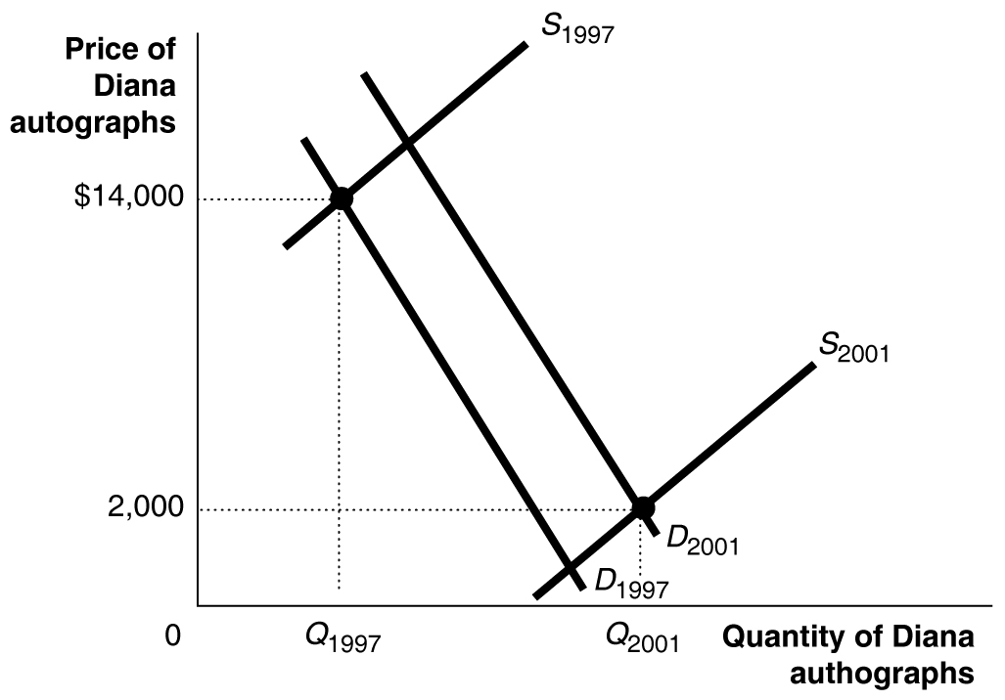
19. c.

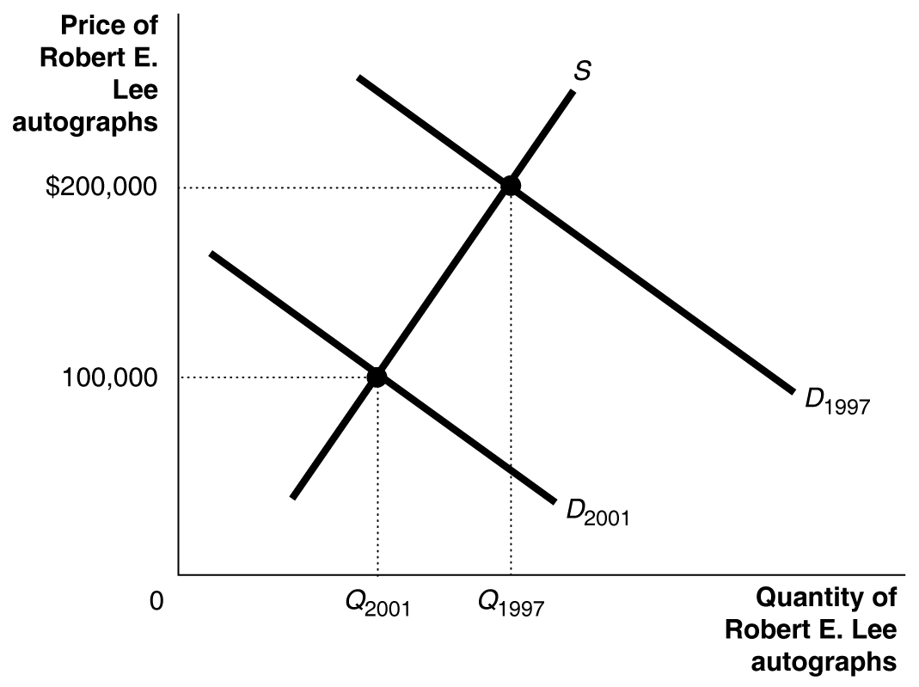

20. Refrigeration allowed for the storage of perishable products. This removed some of the supply during the peak season, shifting the supply curve to the left from S₁ to S₂ and driving the price up from P₁ to P₂. During the off-season, the refrigerated supply could be offered for sale, shifting right the relatively small supply from S₃ to S₄ and causing the price to fall from P₃ to P₄.

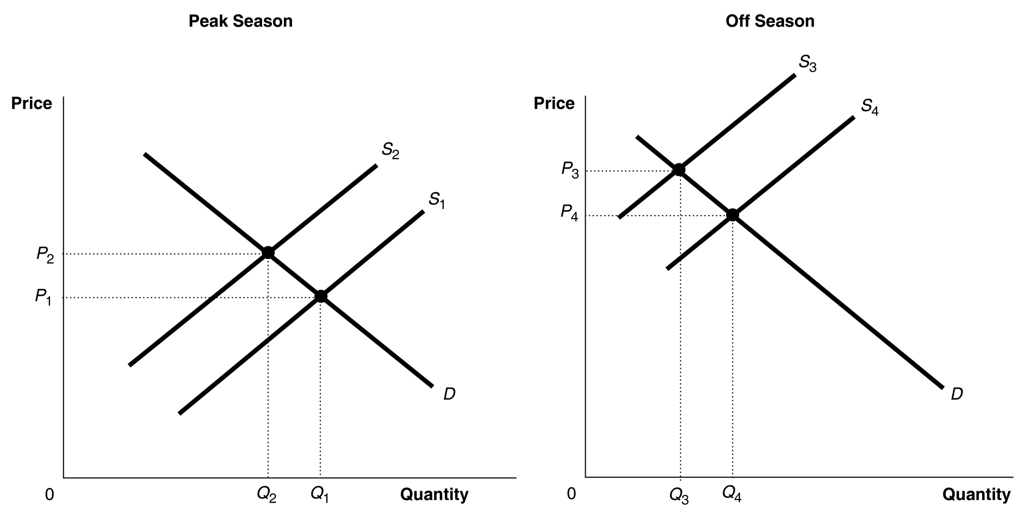

21. a. True
b. False (it depends on whether demand shifts more than supply)
c. False (the price will definitely decrease)

22.

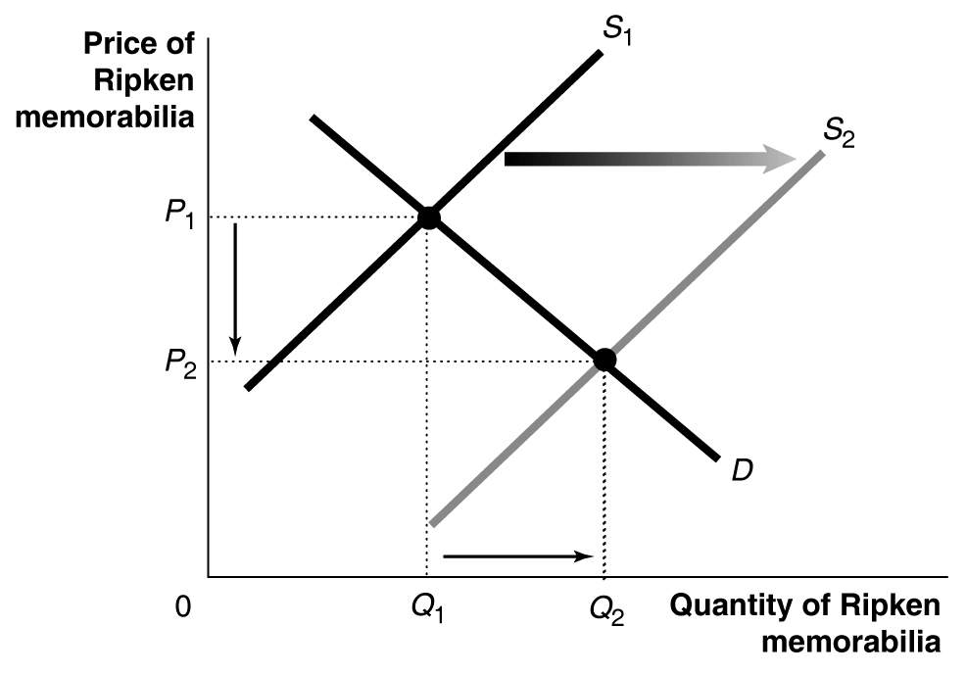

23. The student’s analysis is incorrect: the shift from D₁ to D₂ will not happen.

24. The shift to the left of the U.S. supply curve from S_{US1} to S_{US2} increases the price from P₁ to P₂. In the non-U.S. market, the demand rises from D₁ to D₂ because the price of a substitute (American-grown cotton) had risen. This causes the movement along the non-U.S. supply curve shown by the arrow. (The price of both types of cotton probably rose by about the same amount, if they were close substitutes.)

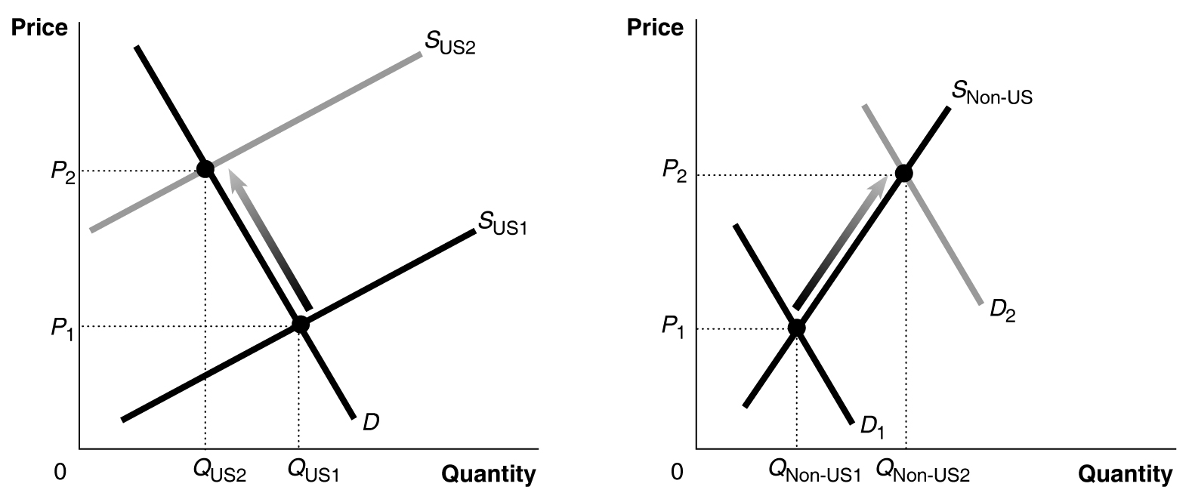

25. The rising costs will cause the supply curve to shift to the left, from S₁ to S₂, while the improvement in quality will cause the demand curve to shift to the right from D₁ to D_{2.} Because we don’t know if demand shifts to the right more than supply shifts to the left, we don’t know if the equilibrium quantity purchased will increase or decrease. If the shift in the supply curve is greater, as shown in the figure, the equilibrium quantity will fall.

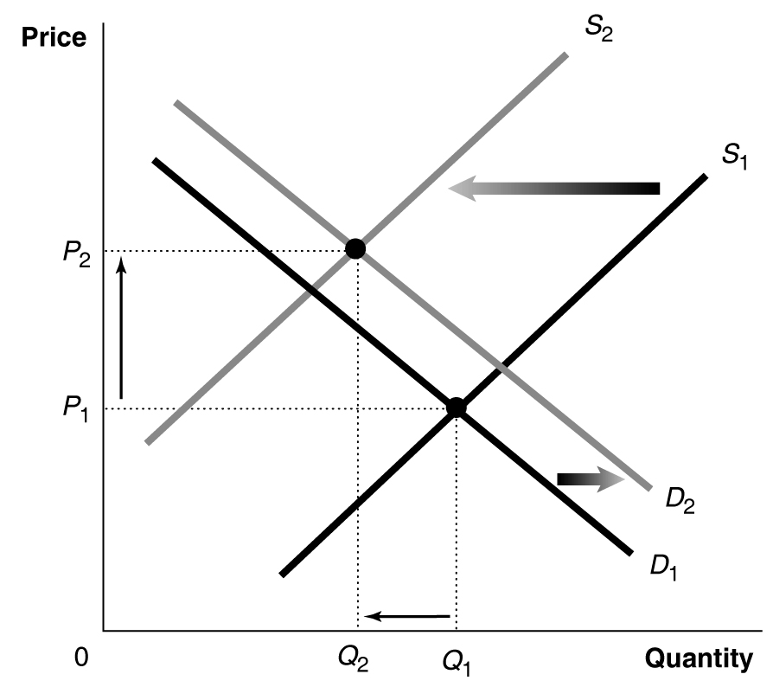

26. The graph with the vertical demand curve is more likely to represent the market for the life-saving drug. If the price of this good rises, patients are unlikely to reduce the quantity they demand, but if the price of the BMW rises, households will reduce the quantity they demand as they switch to buying other luxury cars.

